Dumpling Noodle Soup

7/22/2023:
Used soba noodles
Used 4 cups chicken broth, 2 cups chicken bone broth
Added dumplings, then vegetables, then miso

Broth wasn’t flavorful enough, dumplings that I bought got overcooked and agitated so broke apart, miso didn’t mix very well after everything was added already.

Not enough broth!

By Hetty Lui McKinnon
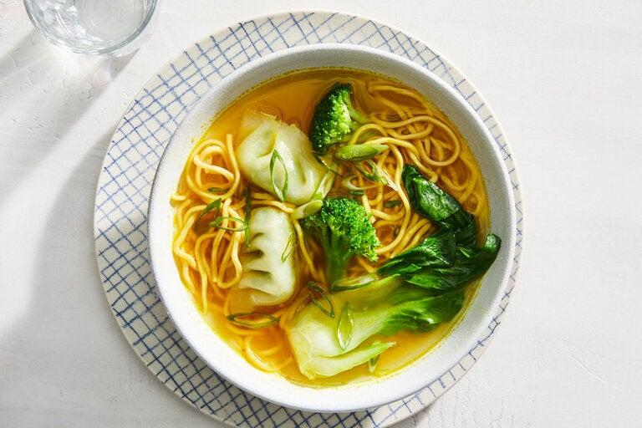
Linda Xiao for The New York Times. Food Stylist; Hadas Smirnoff. Prop Stylist: Megan Hedgepeth.
Time
25 minutes
Rating
4(2914)
Notes
Read 236 community notes
Keep a package or two of frozen dumplings in your freezer for this warming weeknight meal. This recipe is loosely inspired by wonton noodle soup, but replaces homemade wontons with store-bought frozen dumplings for a quick alternative. The soup base, which comes together in just 10 minutes, is surprisingly rich and full-bodied, thanks to the trio of ginger, garlic and turmeric. Miso paste brings extra savoriness, but you could substitute soy sauce or tamari. Scale up on veggies if you like; carrots, peas, snow peas or mushrooms would be excellent additions. Any type of frozen dumpling works in this dish, making it easy to adapt for vegan, vegetarian or meat-loving diners.

INGREDIENTS
Yield:4 servings
- Kosher salt (such as Diamond Crystal)
- 6ounces thin dried wheat, egg or rice noodles
- 1tablespoon sesame oil
- 1(2-inch) piece ginger, grated
- 2garlic cloves, peeled and grated
- 1teaspoon ground turmeric
- 6cups vegetable stock
- 2tablespoon white miso paste
- 16ounces frozen dumplings (not thawed)
- 4baby bok choy (about 12 ounces), trimmed and each cut into 4 pieces through the stem
- 1small head broccoli (about 9 ounces), cut into bite-size florets
- Handful of cilantro or chopped scallions, for serving

PREPARATION
- Step 1
Bring a large pot of salted water to a boil. Add the noodles and cook according to package instructions, until the noodles are just tender. Drain, rinse with cold water and drain well again. Divide them among four serving bowls.
- Step 2
Place the same large pot over medium heat, and add sesame oil, ginger, and garlic. Stir and cook for 30 seconds, until aromatic. Add turmeric, and stir for 15 seconds, until fragrant.
- Step 3
Pour the vegetable stock into the pot, then season with 1 teaspoon of salt. Cover and cook for 8 to 10 minutes on medium heat, to allow flavors to meld.
- Step 4
Remove the lid and add the miso paste, stirring constantly until it is dissolved. Taste, and season with more salt, if needed.
- Step 5
Increase the heat to medium-high, and carefully drop the dumplings into the broth. When they float to the top, add the baby bok choy and broccoli, and cook for about 2 minutes, just until the broccoli is crisp-tender.
- Step 6
Ladle the broth, dumplings, baby bok choy and broccoli into the four bowls over the noodles. To serve, top with cilantro or chopped scallions.

